**SMARTBRIDGE ASSIGNMENT-3**

**NAME: S POOJA**

**REGISTRATION NUMBER: 20MIS0037**

**COURSE: Modern Application Development (Java Spring Boot)**

ASSIGNMENT QN:

**IMPLEMENT JDBC CONNECTIVITY USING JAVA**

DISPLAYING TABLE ELEMENTS:

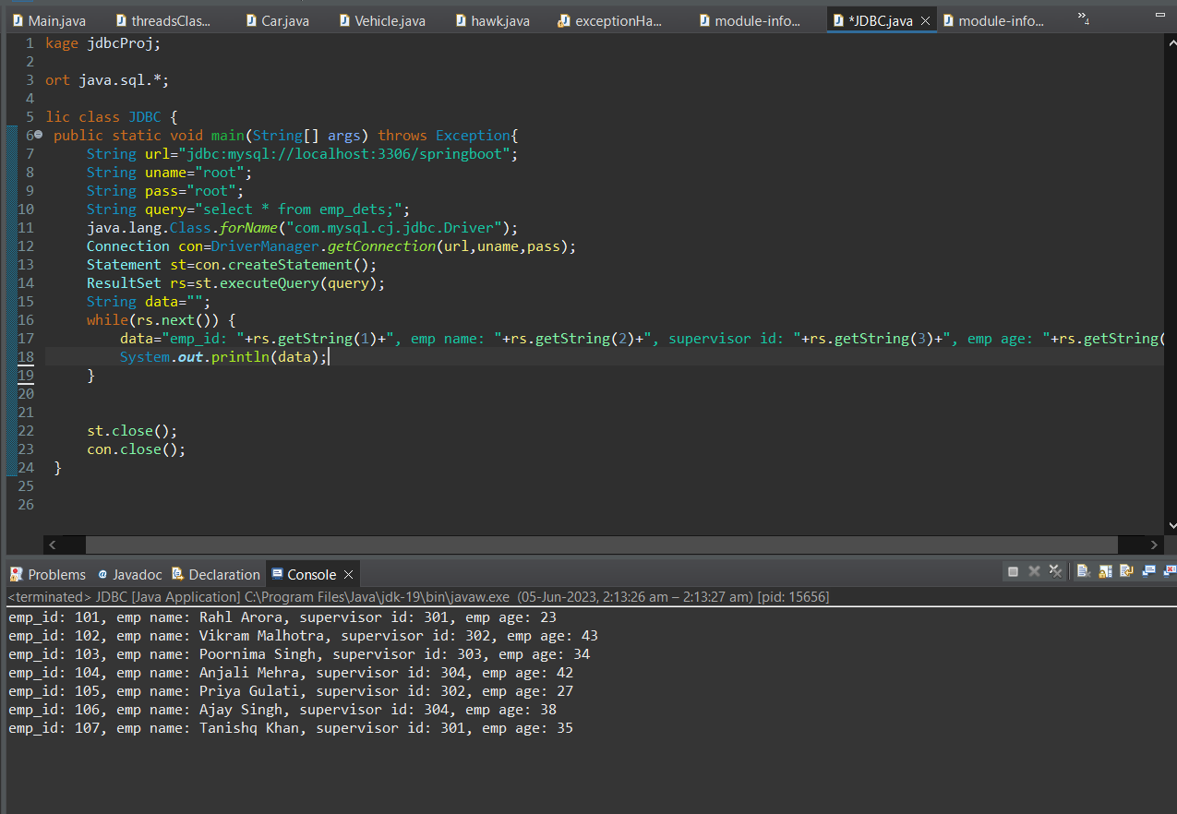

Inserting values and displaying table values:

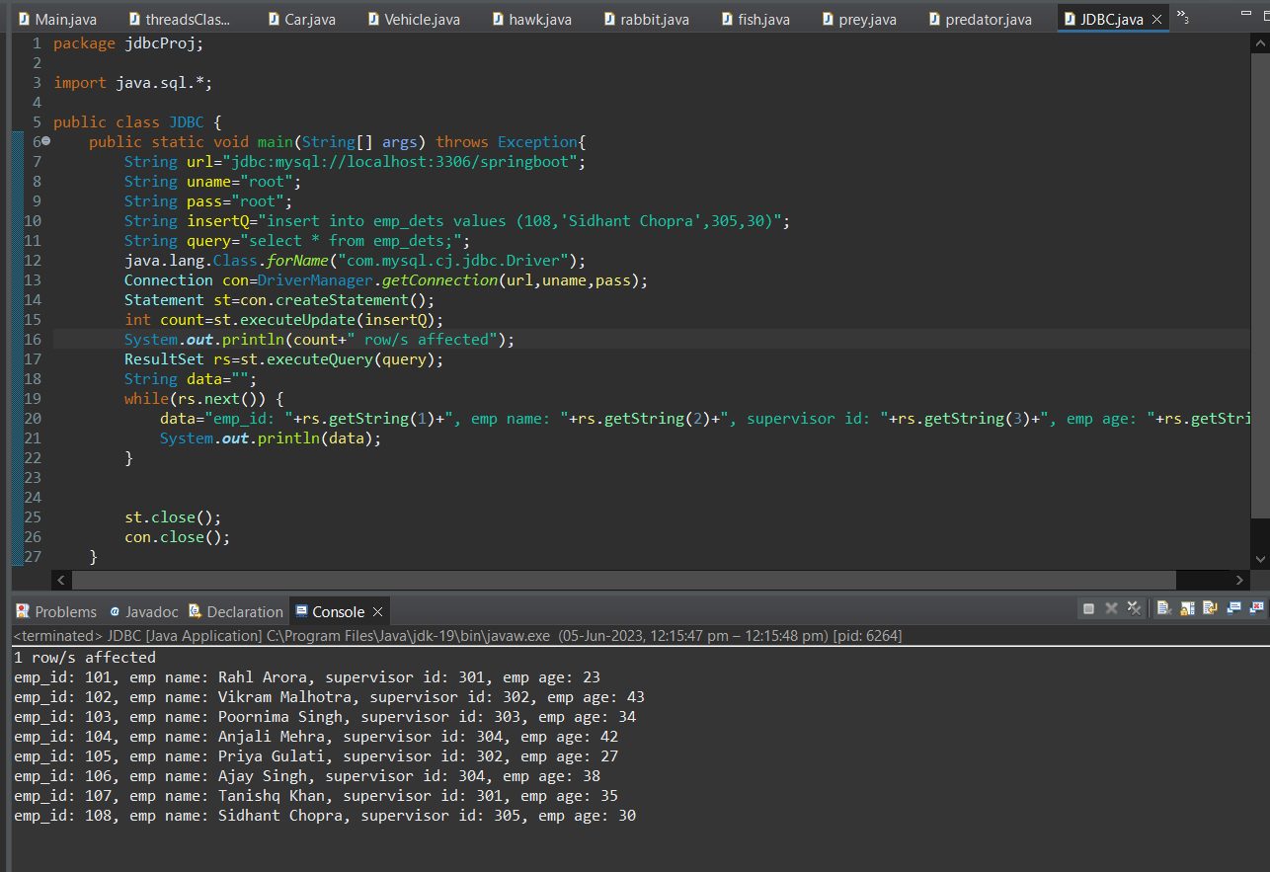

INSERTING VALUES FROM USER INPUT:

package jdbcProj;

import java.sql.*;

import java.util.*;

public class JDBC {

public static void main(String[] args) throws Exception{

String url="jdbc:mysql://localhost:3306/springboot";

String uname="root";

String pass="root";

Scanner sc=new Scanner(System.***in***);

System.***out***.println("Enter emp_id : ");

int eid=sc.nextInt();

System.***out***.println("Enter employee name : ");

String name=sc.nextLine();

System.***out***.println("Enter supervisor id : ");

int sid=sc.nextInt();

System.***out***.println("Enter employee age : ");

int age=sc.nextInt();

String insertQ="insert into emp_dets values (?,?,?,?)";

String query="select * from emp_dets;";

java.lang.Class.*forName*("com.mysql.cj.jdbc.Driver");

Connection con=DriverManager.*getConnection*(url,uname,pass);

PreparedStatement pst=con.prepareStatement(insertQ);

Statement st=con.createStatement();

pst.setInt(1,eid);

pst.setString(2,name);

pst.setInt(3,sid);

pst.setInt(4,age);

int count=pst.executeUpdate();

System.***out***.println(count+" row/s affected");

ResultSet rs=st.executeQuery(query);

String data="";

while(rs.next()) {

data="emp_id: "+rs.getString(1)+", emp name: "+rs.getString(2)+", supervisor id: "+rs.getString(3)+", emp age: "+rs.getString(4);

System.***out***.println(data);

}

st.close();

con.close();

}

}

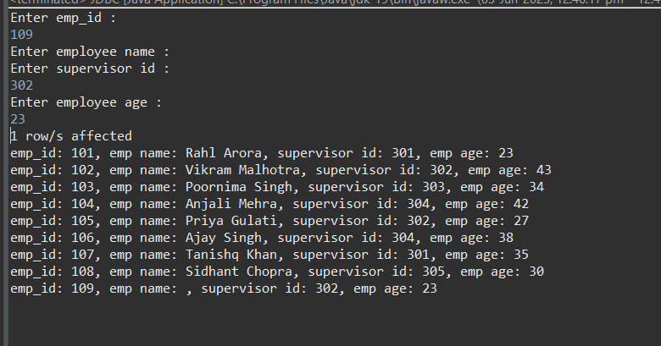

DELETING ROWS:

package jdbcProj;

import java.sql.*;

import java.util.*;

public class JDBC {

public static void main(String[] args) throws Exception{

String url="jdbc:mysql://localhost:3306/springboot";

String uname="root";

String pass="root";

Scanner sc=new Scanner(System.in);

System.out.println("Enter emp_id : ");

int eid=sc.nextInt();

System.out.println("Enter employee name : ");

sc.nextLine();

String name=sc.nextLine();

System.out.println("Enter supervisor id : ");

int sid=sc.nextInt();

System.out.println("Enter employee age : ");

int age=sc.nextInt();

String insertQ="insert into emp_dets values (?,?,?,?)";

String query="select * from emp_dets;";

String deleteQ="delete from emp_dets where emp_id=109";

java.lang.Class.forName("com.mysql.cj.jdbc.Driver");

Connection con=DriverManager.getConnection(url,uname,pass);

PreparedStatement pst=con.prepareStatement(insertQ);

Statement st=con.createStatement();

Statement dst=con.createStatement();

pst.setInt(1,eid);

pst.setString(2,name);

pst.setInt(3,sid);

pst.setInt(4,age);

int count=pst.executeUpdate();

System.out.println(count+" row/s affected");

int dc=dst.executeUpdate(deleteQ);

System.out.println(dc+" row/s deleted");

ResultSet rs=st.executeQuery(query);

String data="";

while(rs.next()) {

data="emp_id: "+rs.getString(1)+", emp name: "+rs.getString(2)+", supervisor id: "+rs.getString(3)+", emp age: "+rs.getString(4);

System.out.println(data);

}

st.close();

con.close();

}

}

